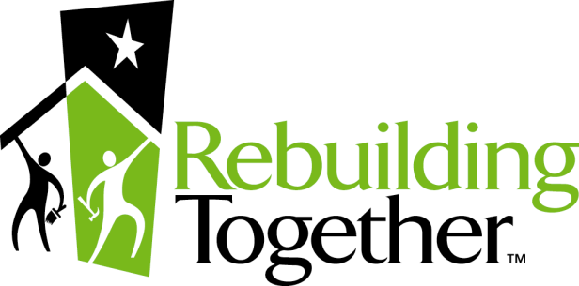

Indianapolis

Assumption of Risk and Release and Waiver of Liability for a Minor Child

We, the undersigned, as parents or natural or legal guardians, hereby request that the below named minor child (“Minor”) be granted permission to assist on a voluntary basis in the Rebuilding Together - Indianapolis Home Repair Project.

In consideration for Rebuilding Together - Indianapolis agreeing to allow Minor to assist on a voluntary basis in the Rebuilding Together - Indianapolis Home Repair project, in which the homes of the elderly, disabled and low income persons will be repaired by volunteers (the “Project”), and in light of the aims and purposes of the community service provided by Rebuilding Together - Indianapolis in organizing this project, we, the undersigned, on behalf of the minor and for ourselves, our personal representatives, heirs, next of kin, spouse and assigns, do hereby:

- Acknowledge that Minor has voluntarily applied to participate in the Project in which homes of elderly, disabled and low-income persons will be required.

- Understand the risks involved in the activity of repairing homes of the elderly, disabled and low-income persons and other activities in which Minor might participate at Project, and accept all responsibility for Minor’s safety and welfare while repairing homes or participating in other activities.

- Understand that repairing homes may be dangerous and that voluntarily participating in the Project is conditioned upon
- my acknowledgment that the activity will or may expose Minor to risk of injury from obvious dangers, hidden dangers, accidents, mishaps, conditions or acts of other persons and that because it is an activity involving dangerous equipment, it is a potentially hazardous activity; and
- my acknowledgement that there is inherent danger in repairing homes which I appreciate and voluntarily assume because the Minor and we choose to do so.

We acknowledge the foregoing and voluntarily, with the awareness of the possible injurious consequences, assume all risk of injury (whether disclosed or not) and do not expect to receive any other warning or other information concerning the possible risks of injury.

- Agree that in consideration for allowing the Minor to participate in the activity of repairing homes, I hereby relieve, release, discharge and hold harmless Rebuilding Together - Indianapolis, its employees, officers, directors, agents, and volunteers (collectively, “Releases”) of all responsibility or liabilities that may result from others who may make a claim for Minor, through Minor, or on behalf of Minor, for all injuries, loss or damage, and any claim or demands therefore, or account of injury to the Minor’s person or property, or resulting from Minor’s injury or death, relating to Minor’s person or property, or resulting from Minor’s injury or death, relating to Minor’s participation, whether caused by negligence of Releases or otherwise.

- Consent to the unrestricted use by the Releases of any photographs, recordings, interview, videotapes, motion pictures, or similar visual or auditory recording of me and Minor created in connection with the Project.

WE HAVE CAREFULLY READ THIS AGREEMENT AND FULLY AGREE WITH ITS TERMS: WE UNDERSTAND AND IT IS A RELEASE OF ALL CLAIMS AND SHALL BE LEGALLY BINDING UPON US.

DO NOT SIGN IF YOU DO NOT UNDERSTAND OR DO NOT AGREE WITH THE TERMS OF THIS AGREEMENT.

Printed Name _____________________________ Minor’s Printed Name ____________________________

Parent/Guardian Signature ____________________________________ Date

